**Tourism Management System**

Project submitted to the SRM University – AP, Andhra Pradesh

Submitted in partial fulfillment of the requirement for the award of the degree of

**Bachelor of Technology in**

**Computer Science and Engineering**

**School of Engineering and Sciences**

Submitted By

**Jupalle Rohith Kumar|AP21110011423**

**Ambati Sai Teja |AP21110011435**

**Pasupula Harsha |AP21110011450**

**Vaka Rohith |AP21110011463**

**Salapu Guna Sekhar |AP21110011476**

Under the guidance of

**Bhaskara Santhosh Egala**



**Department of Computer Science and Engineering SRM University, AP**

**Neerukonda, Mangalagiri, Guntur**

**Andhra Pradesh – 522 240**

**November 2022**

**Department of Computer Science and Engineering** SRM University, AP



**CERTIFICATE**

This is to certify that the work present in this Project entitled **“TOURISM MANAGEMENT** **SYSTEM**” has been carried out by J.Rohith Kumar, A.Sai Teja, P.Harsha, V.Rohith, S.Guna Sekhar under my/our supervision. The work is genuine, original, and suitable for submission to the SRM University – AP for the award of Bachelor of Technology/Master of Technology in **School of Engineering and Sciences**.

Signature of the Supervisor Signature of Head of the Dept.

**Bhaskara Santhosh Egala JATINDRA KUMAR DASH**

**Acknowledgement**

“The pleasure that follows the successful completion of this project would remain incomplete without a word of gratitude for the people and without whose cooperation this project would remain incomplete. It is not mere formality to place a record the tireless efforts, ceaseless cooperation, constant guidance and encouragement of the people closely associated with the assignment but a distinct necessity for the ethnicity and readability of the project.”

The management theories learnt in this semester brought into practice. We have tried to make best use of their opportunity. The work bears the imprint of many persons under whom we did this project.

We are thankful to our instructor **Bhaskara Santhosh Egala**, for his scholarly

guidance, advice and encouragement and also for providing necessary facilities to

carry out the dissertation in prescribed period.

Finally, we are indebted to our course instructor and those people who had helped us in completing this project.

**Abstract**

The project we have done is about **TOURISM MANAGEMENT SYSTEM** and this includes the two categories:

1. Manager
2. Visitor

Based on we selected the options will be visible and we have to choose and the process will be continued.

Our Tourism Management system is a complete tourist fully integrated tourism console based operative system. The main module in this project is bus registration, number of seats available, Staff management.

Recommender system development emerged from the general idea that individuals rely on others to take regular decisions in their life. The explosive growth in volume and variety of information available on the web has contributed to the development of recommender systems which has, in turn, led to an increase in profit and benefits to the user.

The purpose of Tourism Management system is to keep tracking of the bus. It means that which bus should be driven by which driver and which bus will have to go.

**Contents:**

**Table of Contents:**

Certificate 2

Acknowledgement 3

Abstract 4

Table of Contents 5

Introduction 6

System Requirements 7

Methodology 8

System Implementation 9

Conclusion and Remarks 14

Future Works 14

**Introduction**

The purpose of creating this project is to simplify the process of bus registration, staff management, Booking system Management and any other relevant information.

The workspace and the work required can also be reduced. This Tourism Management system will allow you to add, modify or edit, search and delete the data.

The concepts of functions, classes, operator overloading, ofstream and ifstream concepts, manipulating data is often used in this project. This can be used by any person who has a basic knowledge in computers.

* 1. **Overview of the project**

In this project we will work on staff management like adding staff, removing staff, bus management system like which bus has to go and number of seats are under reserved and how many seats are vacant.

This code allows us to change, delete or modify data that is stored. An effective Tourism Management System will be based on standard operating procedures and best practices, leaving little or no room for error.

Visitors find it easier to manage the huge number of choices in the travelling. Now he can choose his comfortable bus and he may enjoy the travelling.

**System Requirement Specification:**

The project can be accessed or developed under this criterion only

**Software Requirements:** Any Windows

**Environments**: Any online compilers as well as efficient IDE’S.

**Hardware Requirements:**

Hard disk drive:100 GB and cloud data if needed

RAM: Minimum 2 GB

Processor: Intel core i3 or AMD Ryzen 3

**Requirements For Software Development:** Windows 7 or up are required. The system must be connected via LAN and connection to internet is mandatory, only if you have cloud system or actually not necessary.

**Methodology:**

This is just the code work of the Tourism Management system with user interference. We wrote this code in C++ programming language which is object-oriented, middle level programming language.

In this project we are using classes we need exception handling to handle the errors that pop when there is an error.

For doing this project we must have a pre requisite knowledge about functions, classes, file handling, manipulating data, operator overloading…etc

The prerequisites for this project are basic understanding in C++ concepts such as functions, object-oriented concepts and data handling concepts.

Iterative Loops and object-oriented concepts are the most used methodology in this project.

**Working of this Project:**

Basically, the manager has to hire some drivers for 5 buses and we are forcing him to do so by blocking all other options until he hires some staff. After hiring 6 drivers the manager has to input the details of the buses by installing data of the buses who drivers will be assigned from the database itself, so the manager has to just input the details of bus1, bus2, bus3, bus4, bus4, bus5 respectively.

After that we will enable visitors to register/login so that they can reserve or cancel their updated seats and the seats they booked but the information of the passengers will not be displayed as per our protocol.

As we said we are maintaining an effective database of the drivers and any number of visitors will be allowed.

**System Implementation: -**

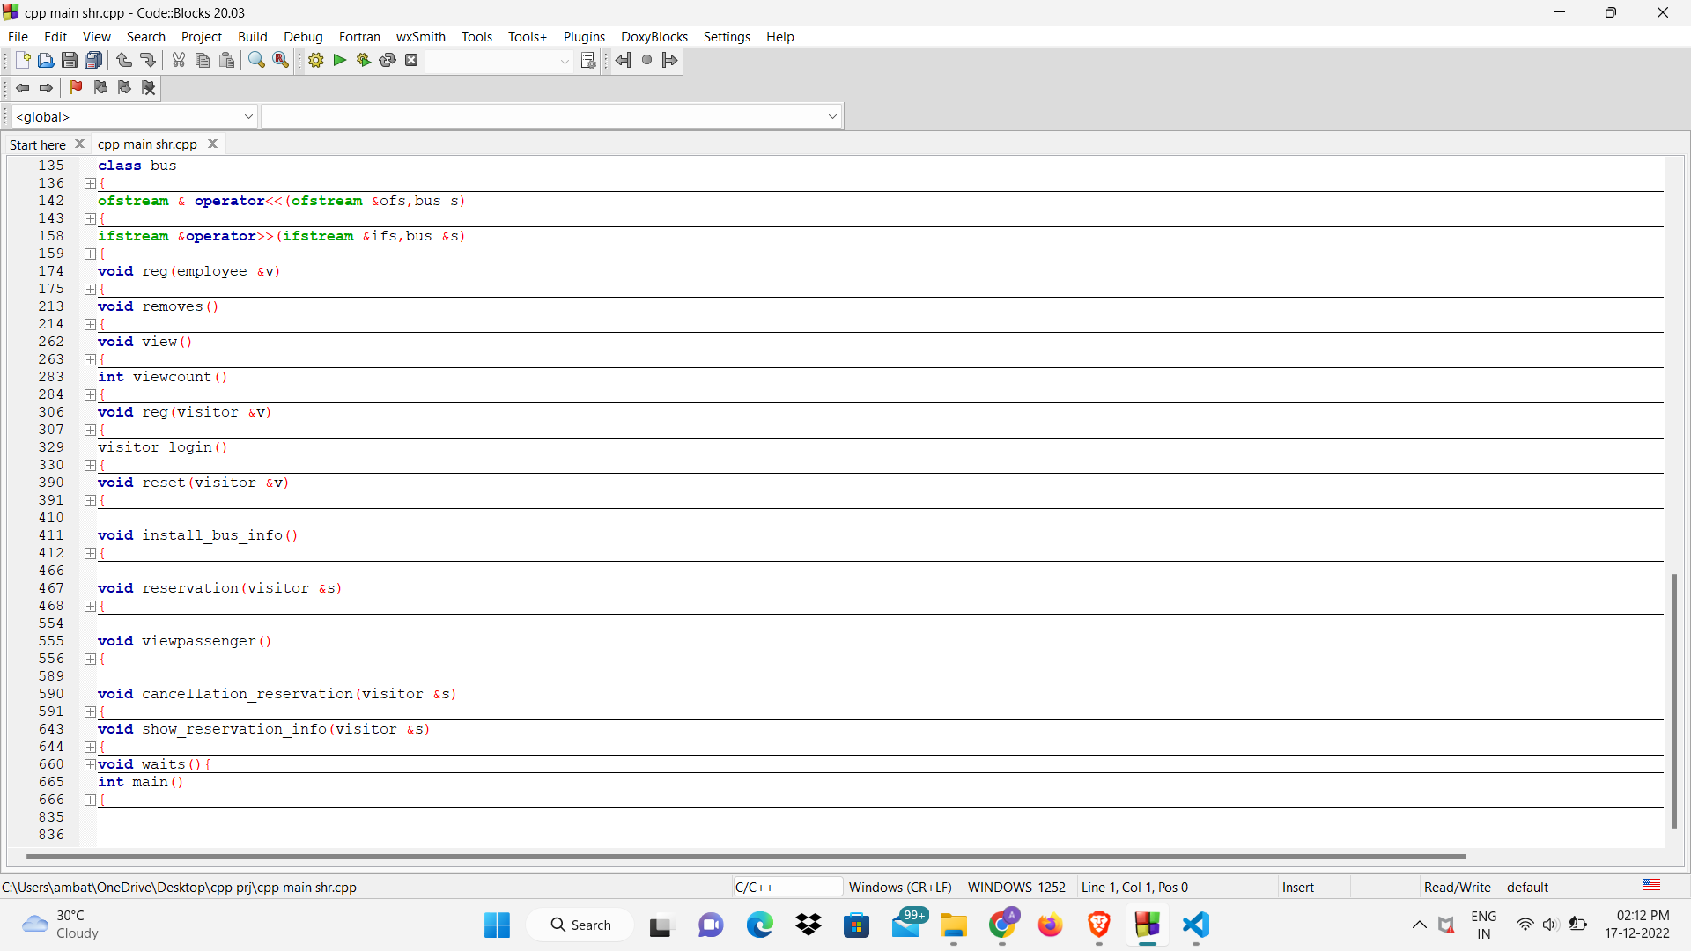

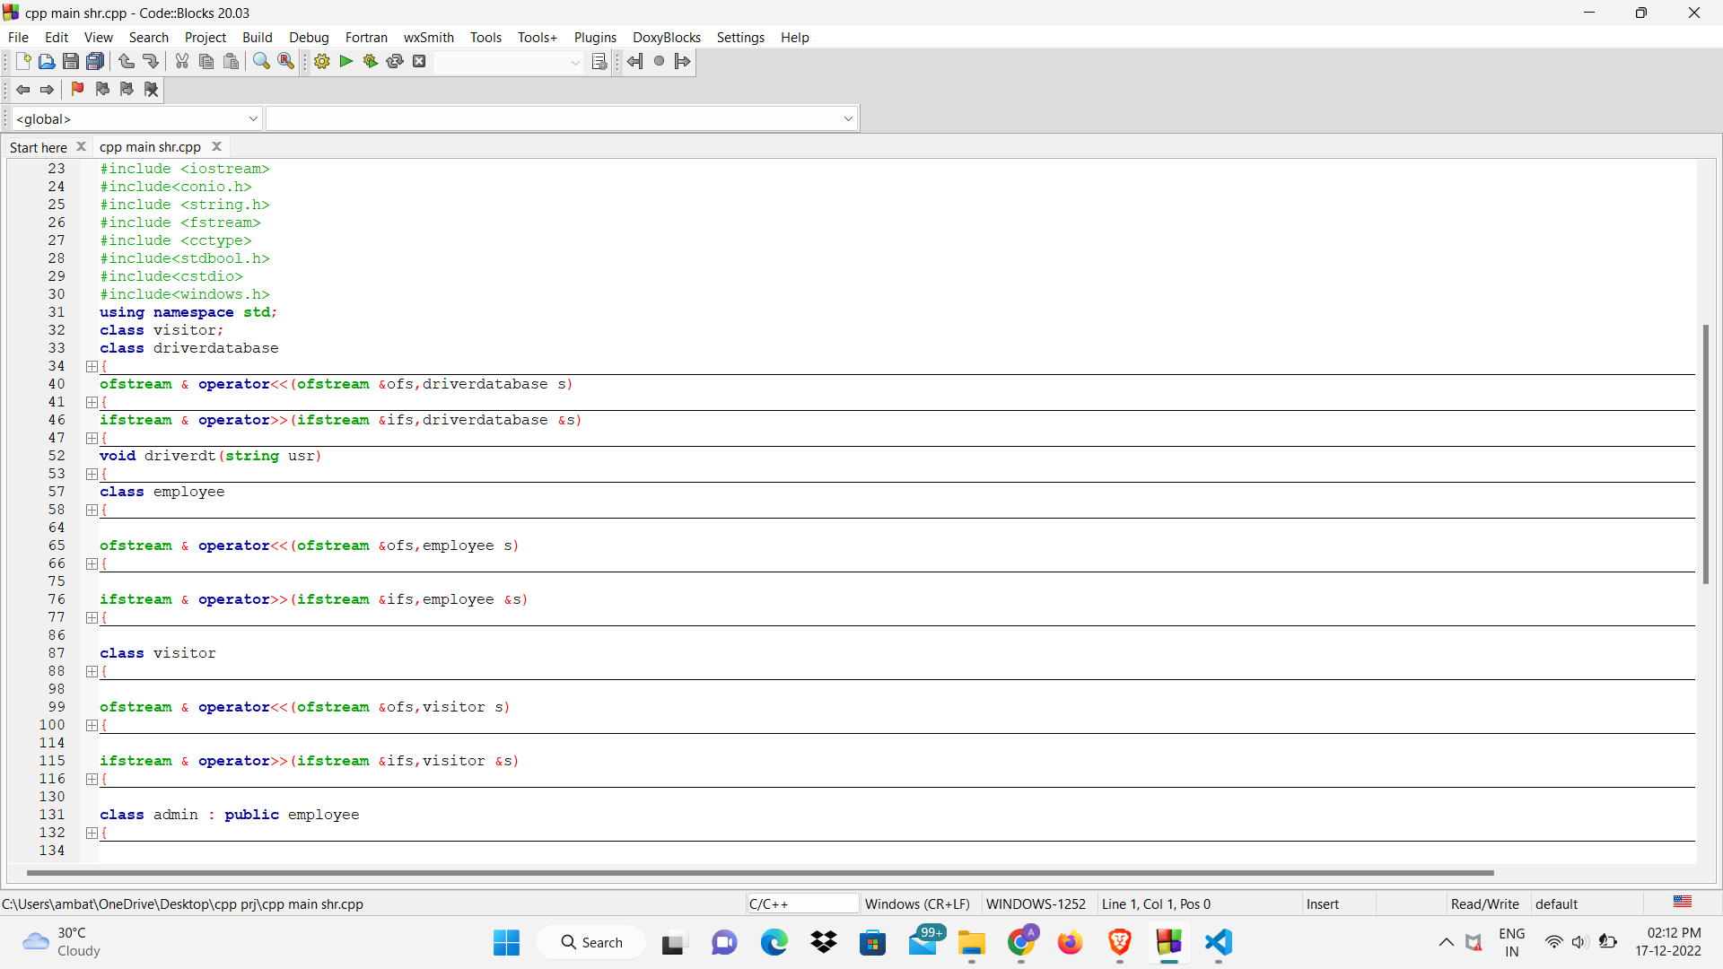**Code: -**

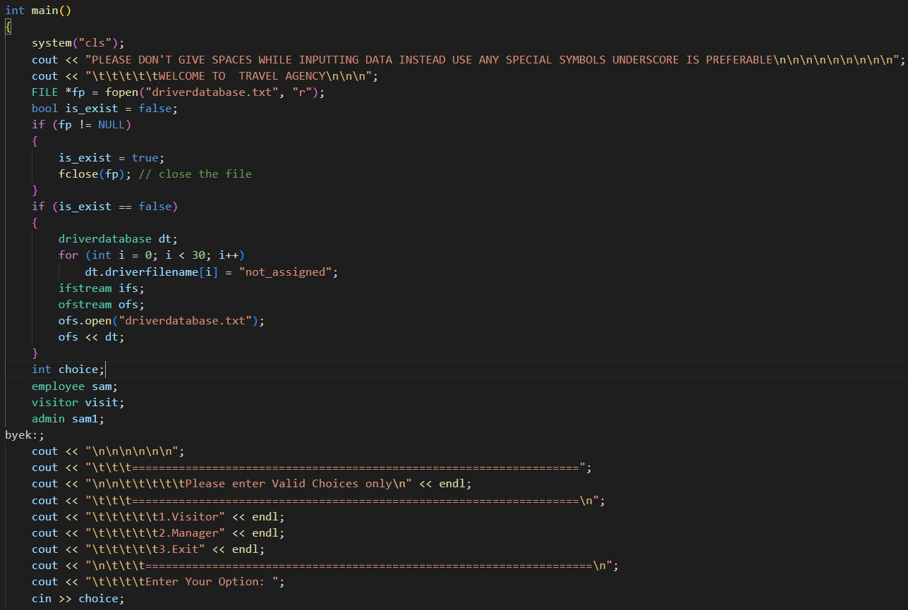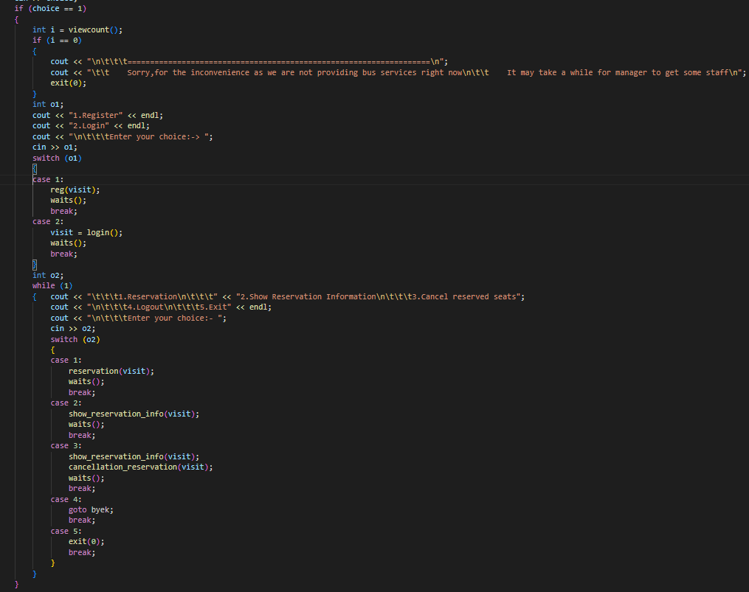

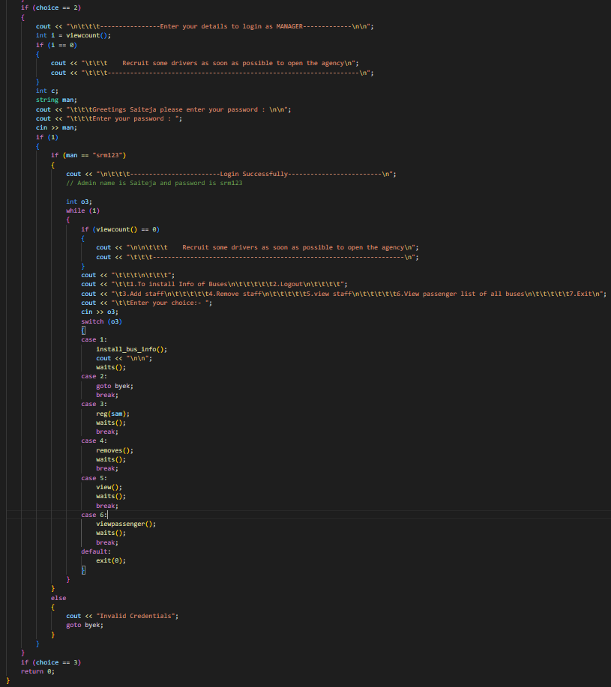

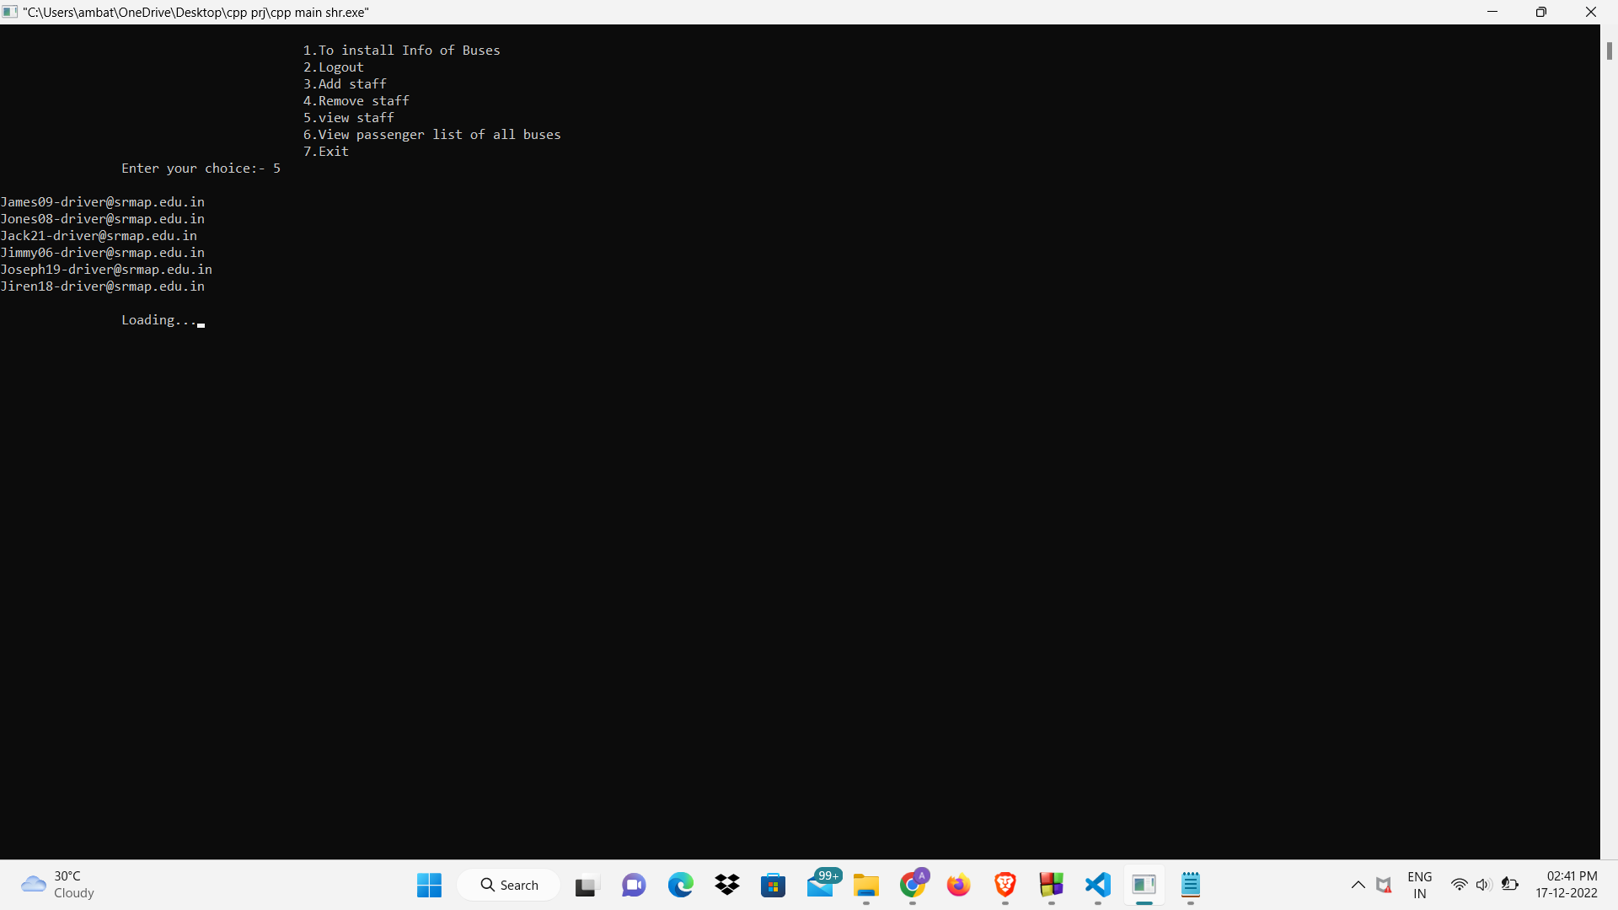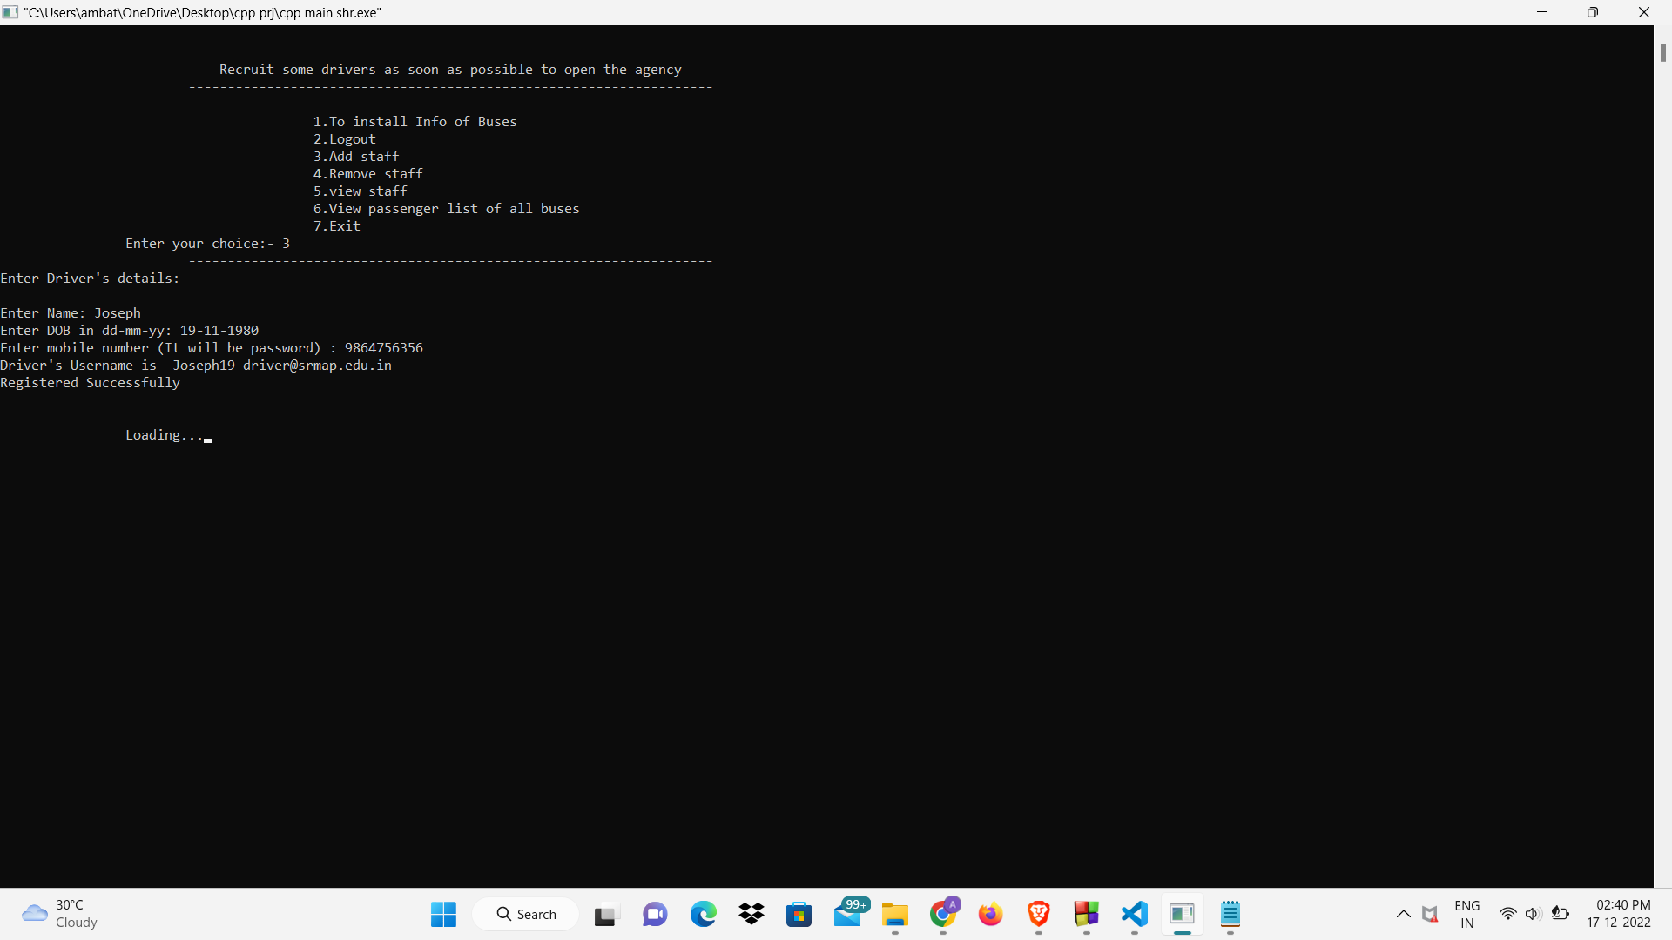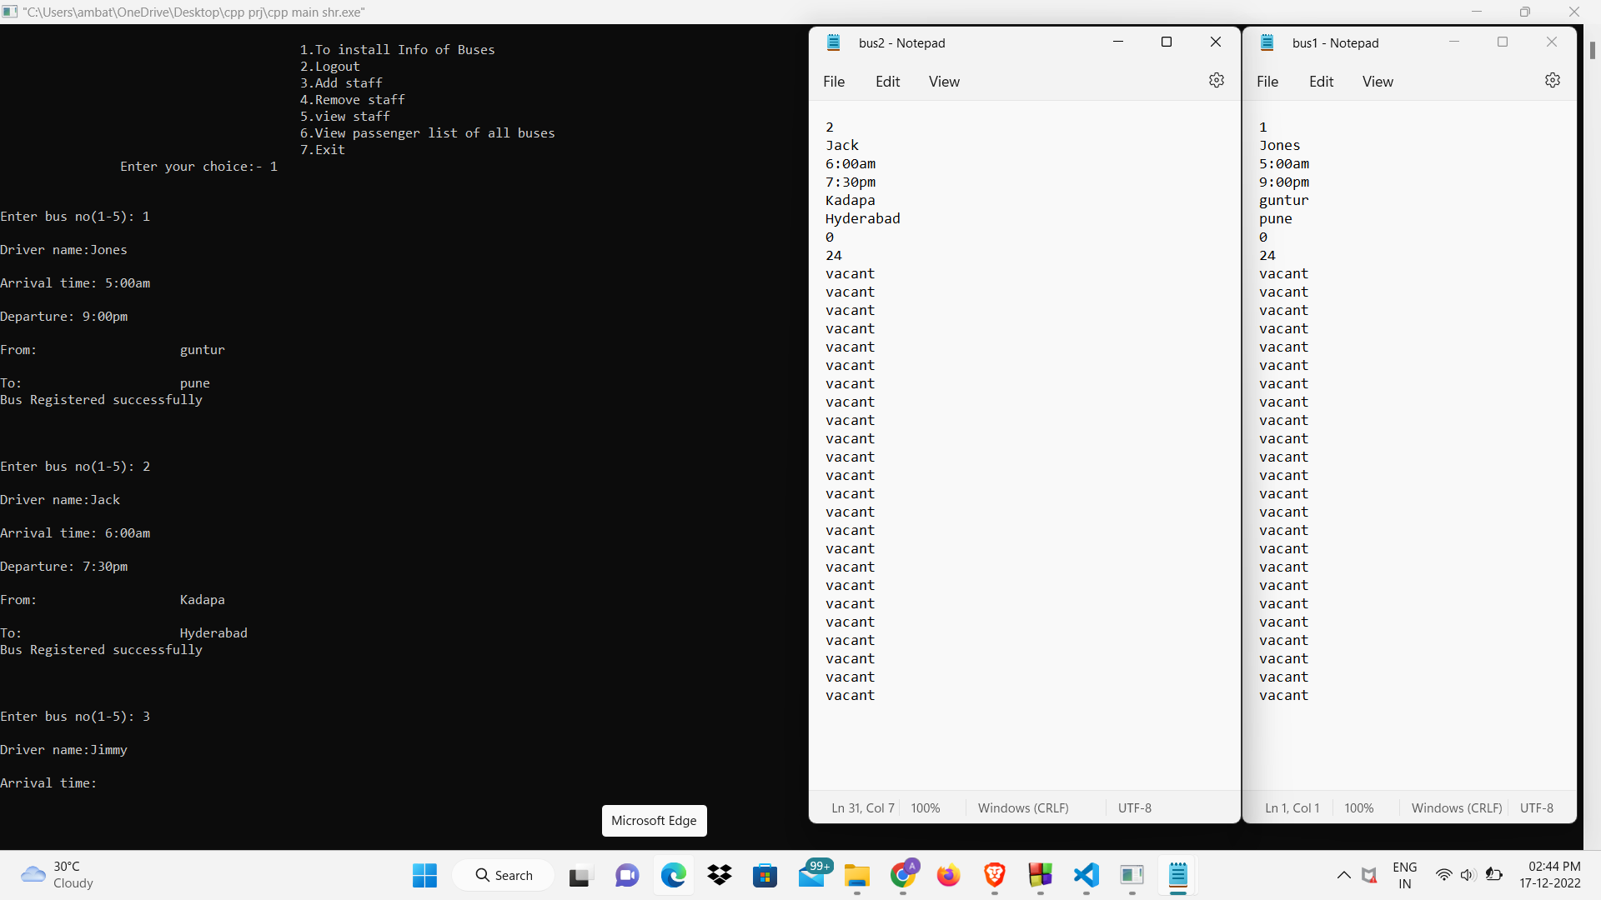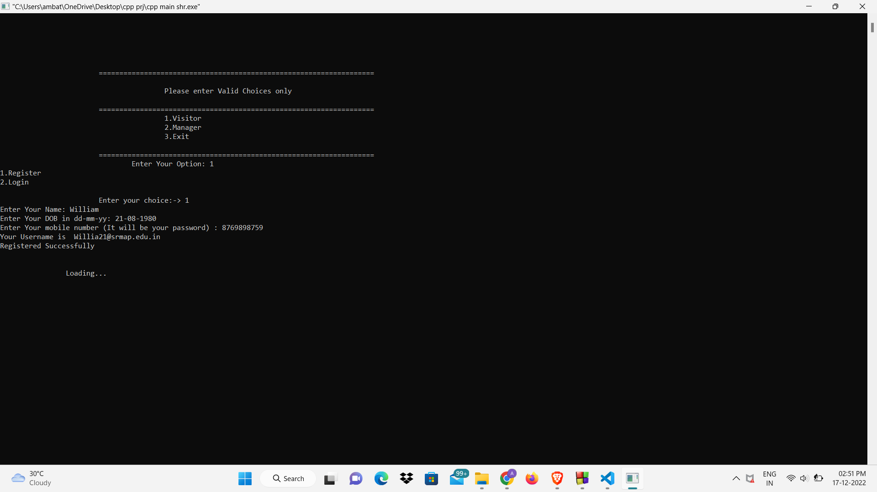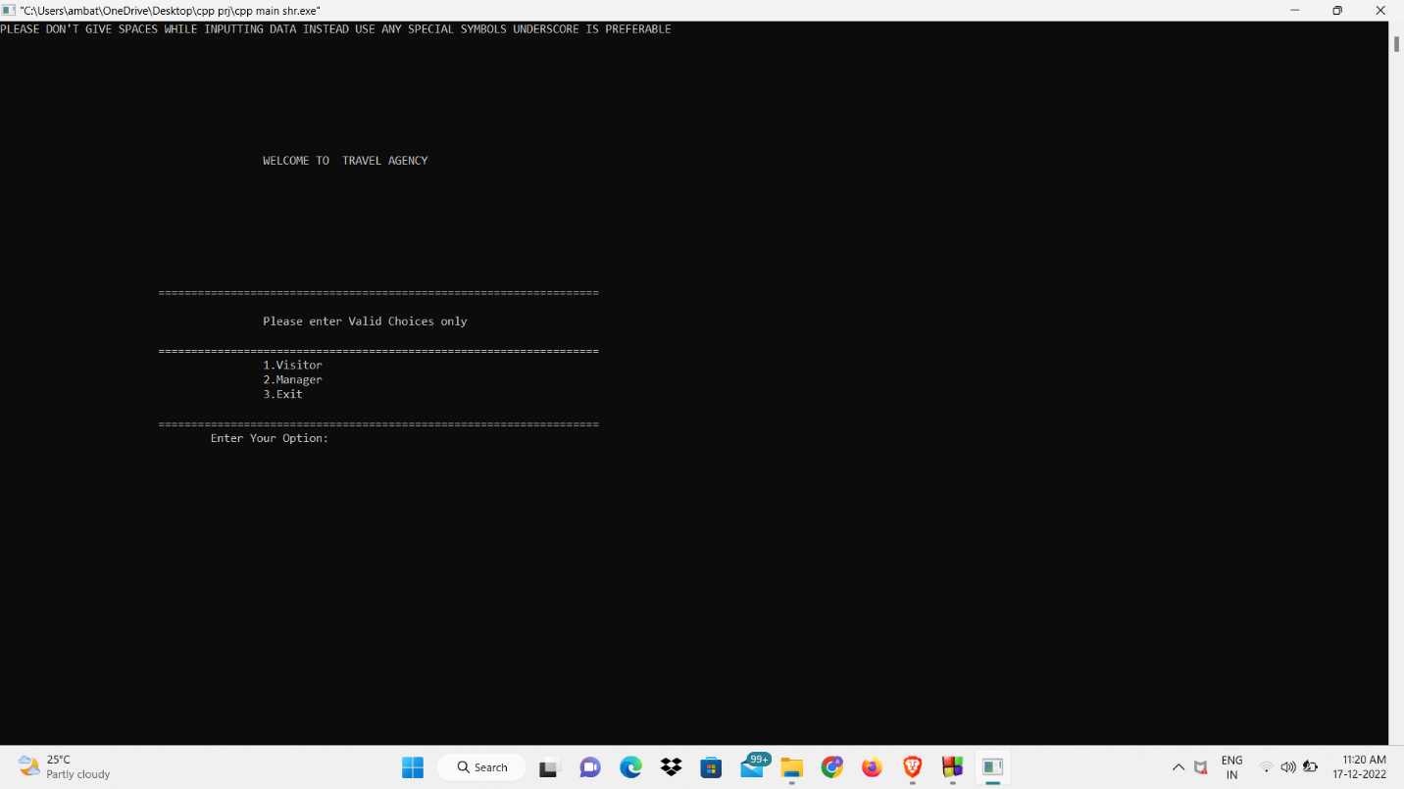**Output: -**

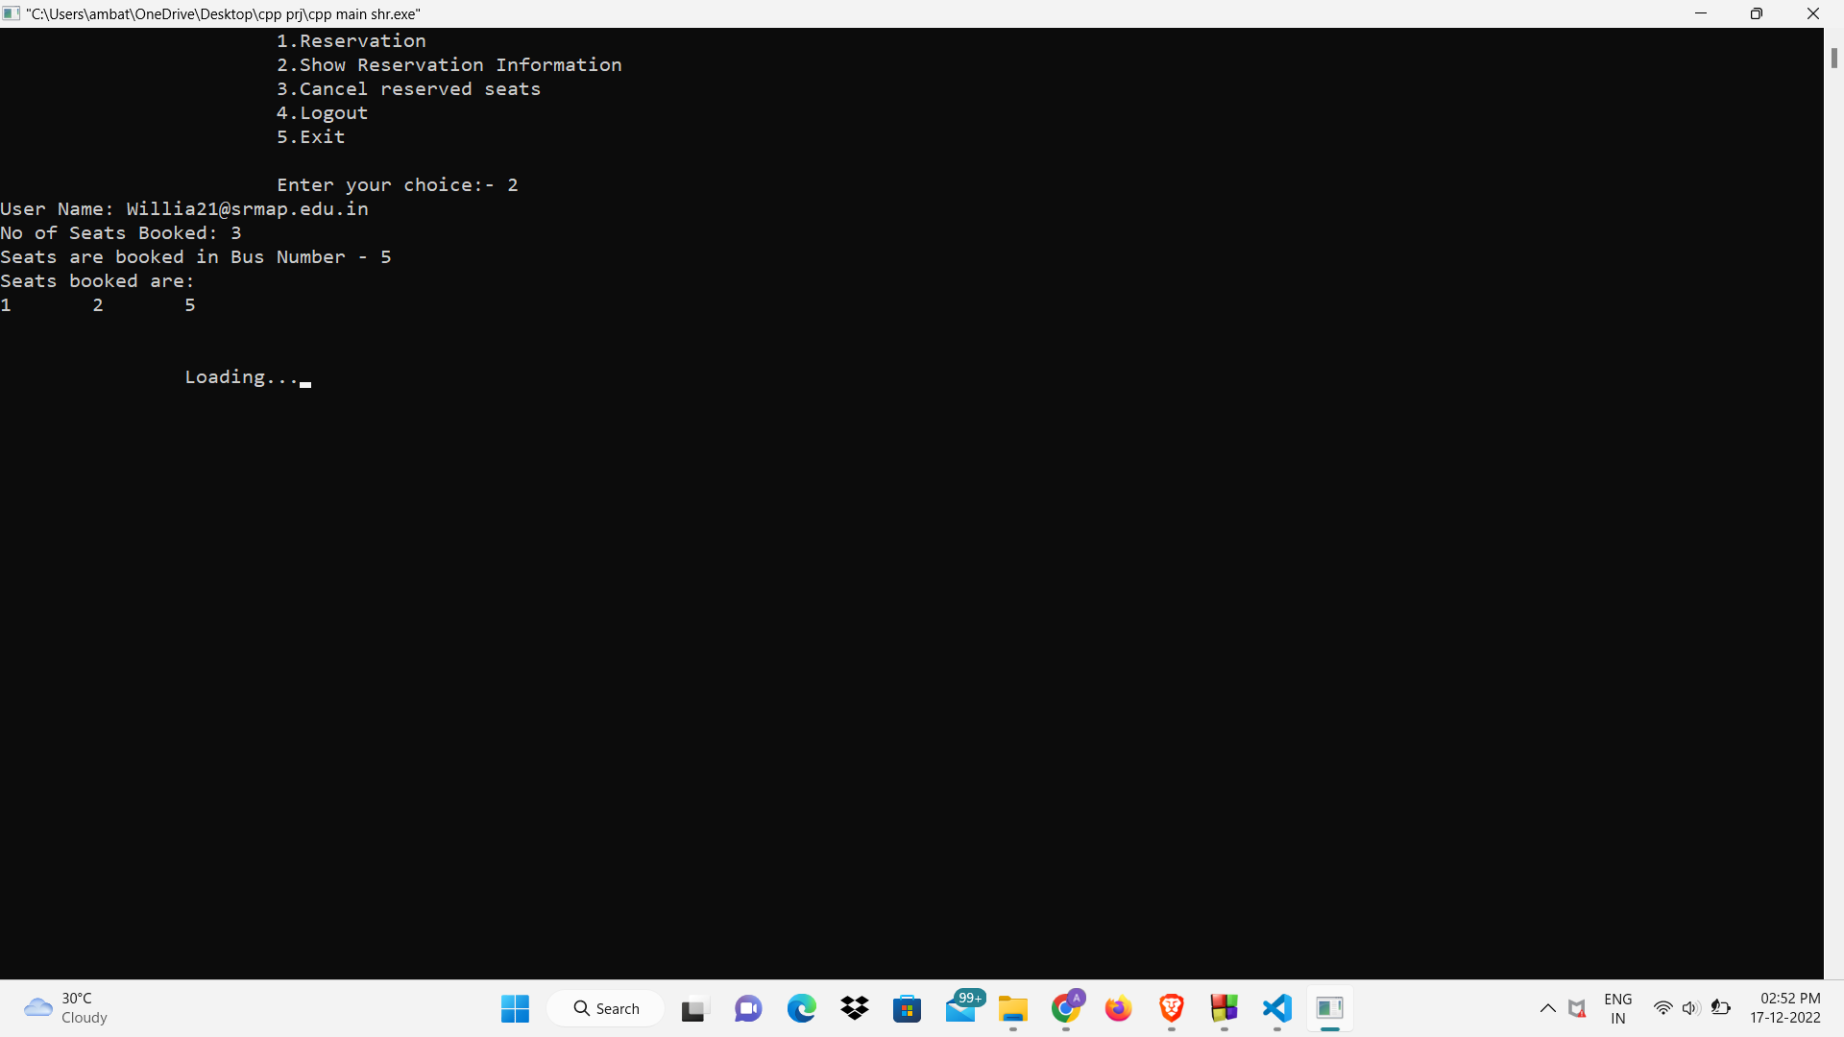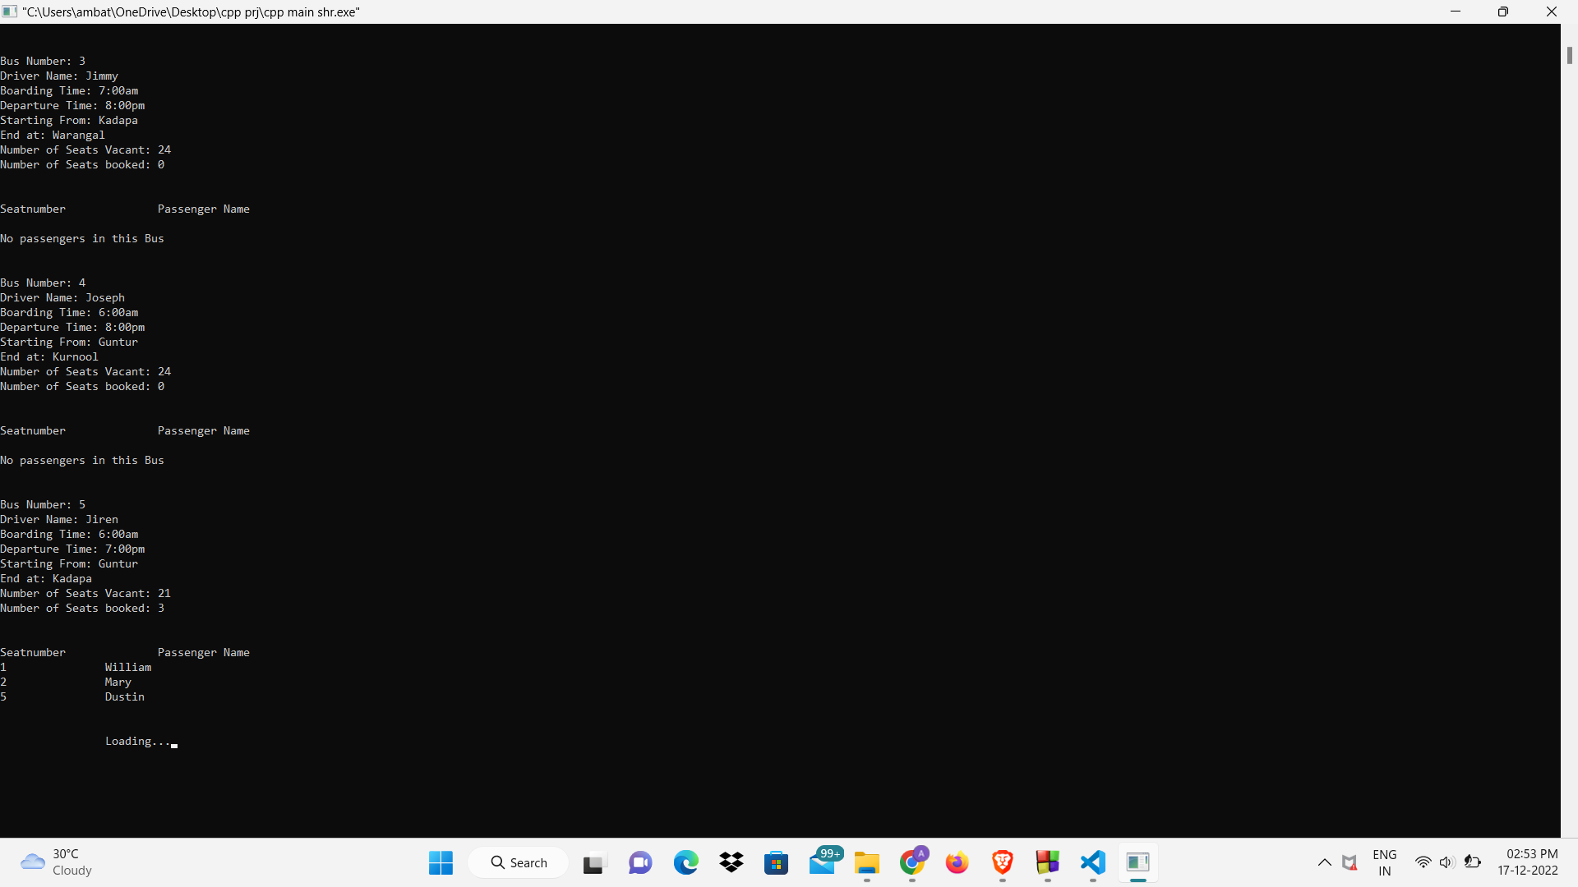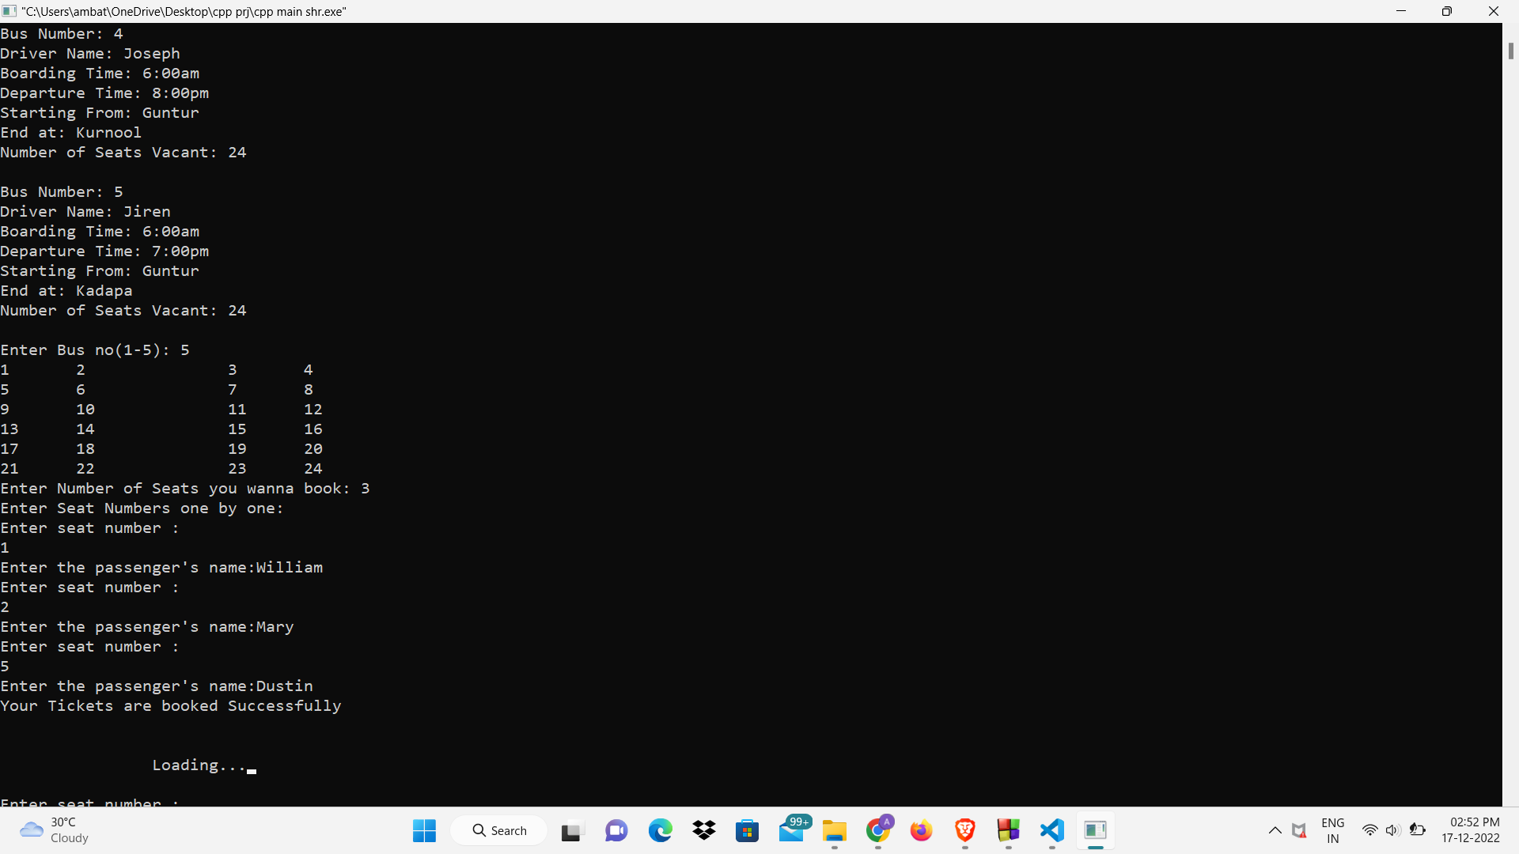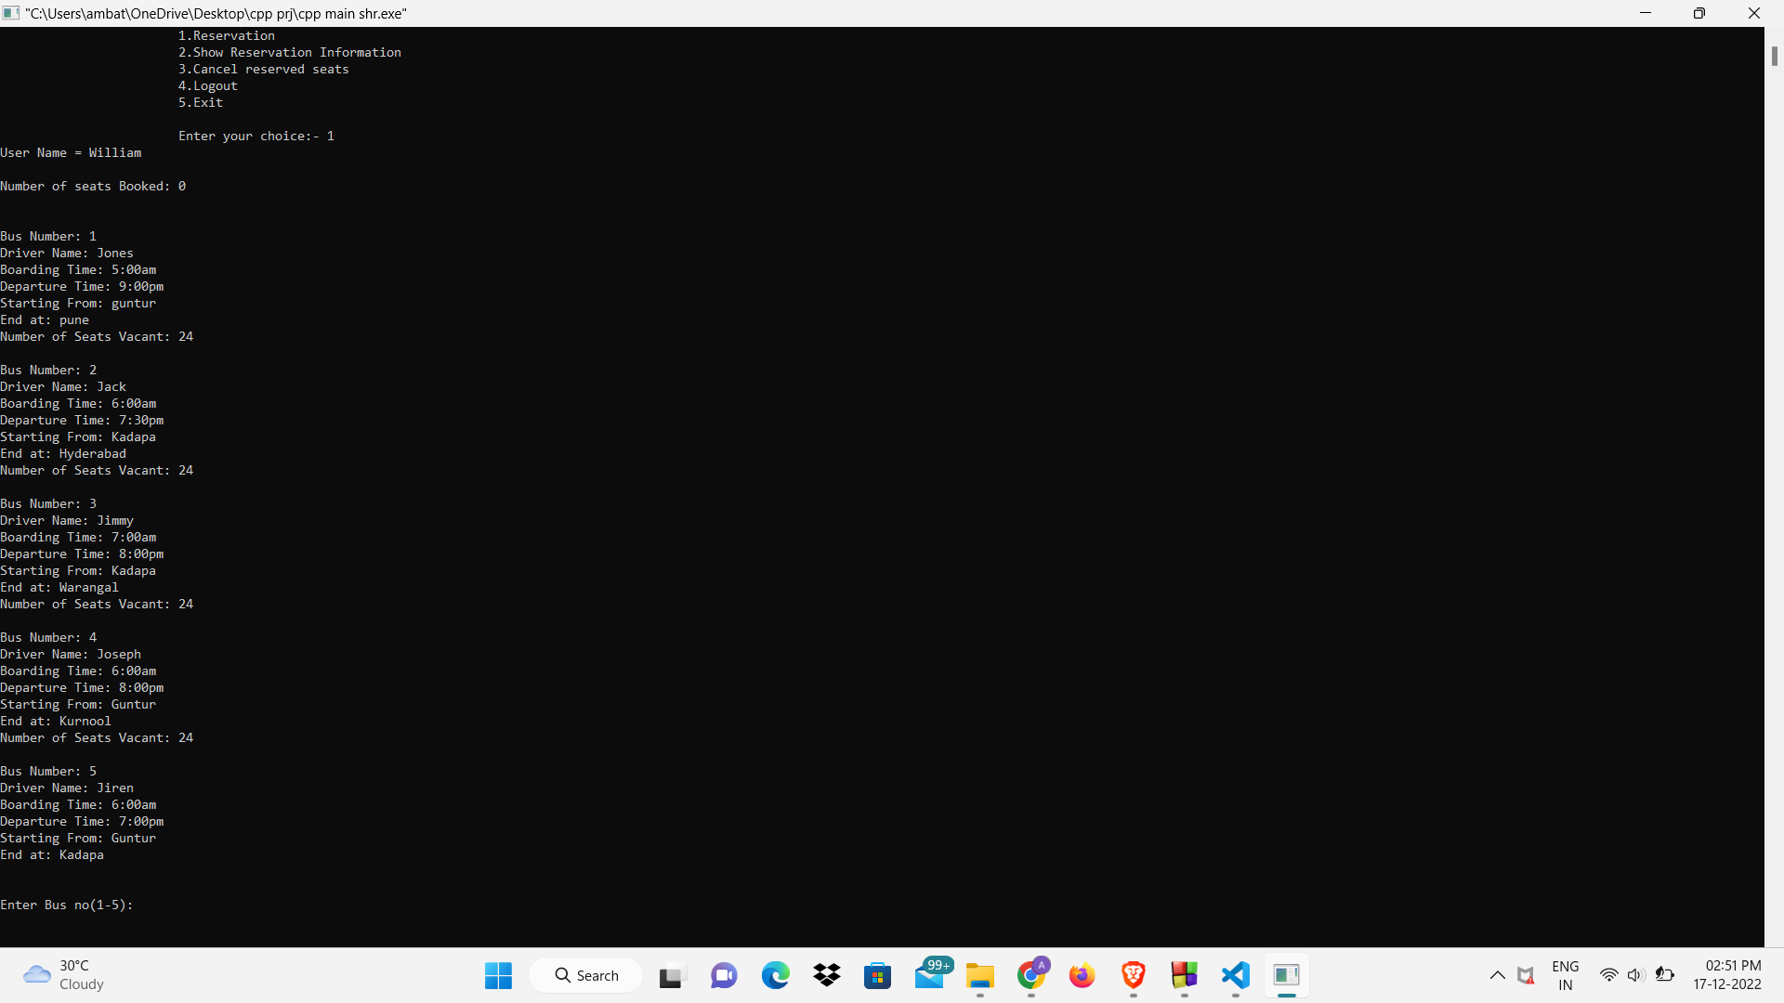

**Conclusion and Remarks: -**

Tourism Management system is a vital system, in order to achieve a productive flow of choosing branch according to his interests. The major use of this project is to store data in the database, so that it checks the interests of the visitor and bus simultaneously and takes his inputs. The main moto of this project is to digitalize the data logging process, initialization of this process is done by C++ due to its versatility and liability, the chance of integrating it with many modules.

The Tourism Management system is for computerizing information of the buses and travellers. It is a great improvement over the manual system. The computerization of the system has speed up the process.

By this project we understood about the working of functions, operator overloading, file handling, object-oriented programming concepts.

Giving a user-friendly interface besides not using any front-end development made the usage of the interpreter up to the mark, and thus we can conclude the Tourism Management System is crucial and can be satisfied by using C++ programming language with some inbuilt modules.

**Future Works: -**

The futuristic vision of this project is to add database servers for this entire data, using modules like tkinter, panda for data handling. Storing log details in the cloud for end-to-end encryption of data. Developing a software or a website to configure and manage the data of whole engineering branch entity. Using object orientation concept for many sub sectors of branches, this makes the system more reliable.

Using the data of this managing system and creating a data model which includes semi supervised learning and some of the former artificial intelligence techniques. This includes the predictions of the student in which course he has to select based on his interests and capabilities.

Developing a user-friendly application, which has a biased front-end showcasing

different aspects and options for user and admin, integrating the application with

fintech enterprises for transactions, which makes this management system more

reliable.